ITAI 2374 • Assignment 1

Glossary of Robotics, AI, and Autonomous Systems

Robot Operating & Autonomous Systems & Platforms
Name: Rich Fox
Date: September 20, 2026
Course: ITAI 2374 – Robot Operating Sys & Platform
School: Houston City College
Instructor: Sitaram Ayyagari

About This Glossary
This glossary explains 26 key terms from robotics, AI, operating systems, and autonomous platforms. Each term has a plain-language definition, an example, and a visual aid. Terms are in alphabetical order. Many examples use PiDog, the quadruped robot from our labs, and they follow ideas from Modules 1 and 2. All diagrams and charts were created for this glossary.

Terms at a Glance
01 Actuator | 14 Large Language Model (LLM)
02 Artificial Intelligence (AI) | 15 LiDAR
03 Autonomous System | 16 Localization
04 Battery Management System (BMS) | 17 Machine Learning in Robotics
05 Computer Vision | 18 Motion Planning
06 Control System | 19 Multimodal AI
07 Deep Learning in Robotics | 20 Pathfinding
08 End Effector | 21 Perception
09 Function Calling / Tool Use | 22 Reinforcement Learning
10 Gait | 23 Robotic Operating System (ROS)
11 Human-Robot Interaction (HRI) | 24 Sensor Fusion
12 Inertial Measurement Unit (IMU) | 25 Servo Motor
13 Kinematics | 26 SLAMS(Simultaneous Localization and Mapping)

Glossary

Actuator
Definition: The part of a robot that makes it move. It takes an electrical signal plus power and turns them into motion, such as spinning, pushing, or bending. If sensors are a robot's senses, actuators are its muscles.
Example: In PiDog, small motors in the legs, head, and tail are the actuators. When the Raspberry Pi says “sit,” the hip and knee actuators bend to lower the body. Wheel motors and gripper motors are actuators too.
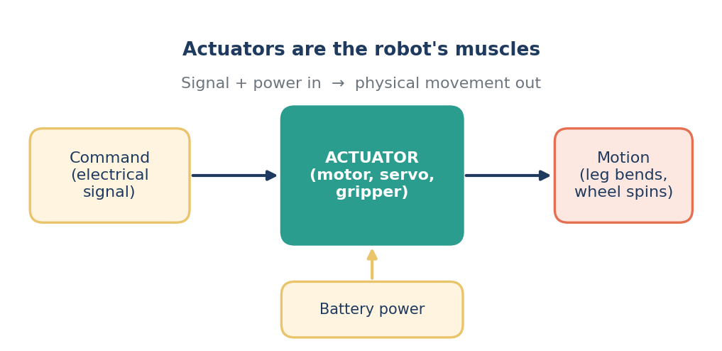
Figure: An actuator turns a command and battery power into movement.

Artificial Intelligence (AI)
Definition: Computer software that does things that normally take human thinking, like recognizing a face, understanding speech, or making a decision. In robotics, AI helps a robot understand what is around it and choose what to do next instead of just repeating fixed steps.
Example: A delivery robot uses AI to tell a person apart from a mailbox and slow down when someone steps in front of it.
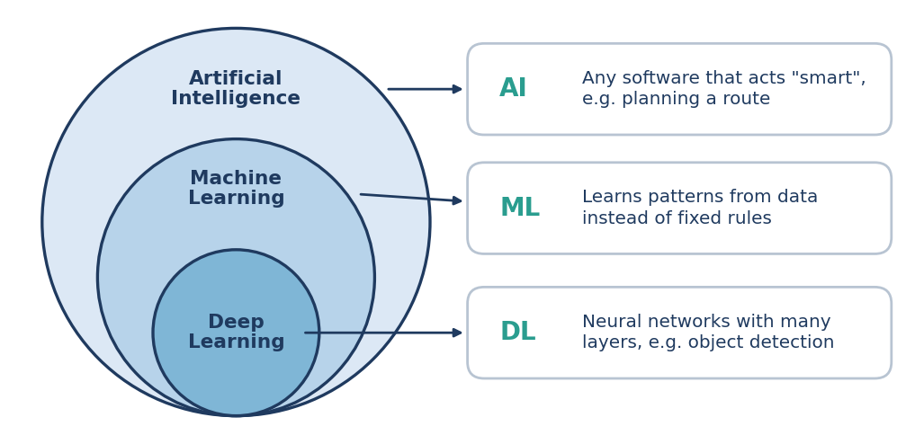
Figure: AI is the big idea. Machine learning and deep learning are smaller parts inside it.

Autonomous System
Definition: A machine that can sense its surroundings, make its own decisions, and act on them with little or no human control. The key idea is that it can handle changes on its own, without a person steering every move.
Example: PiDog can notice an obstacle with its ultrasonic sensor and decide by itself to stop or turn. Robot vacuums and self-driving cars work the same way.
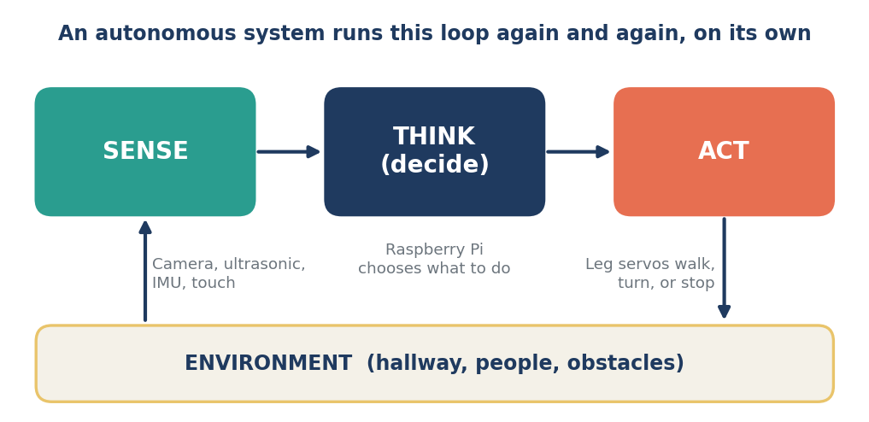
Figure: The sense → think → act loop that an autonomous system repeats.

Battery Management System (BMS)
Definition: A small electronic “guardian” for a battery pack. It watches the voltage, current, and temperature of the cells, keeps the cells evenly charged (called balancing), and cuts power if something looks unsafe, like overheating, overcharging, or too much current.
Example: A robot that runs on a rechargeable lithium battery pack, like a PiDog-style robot, needs a BMS so the battery is not drained too far or overcharged. It also helps estimate how much charge is left so the robot knows when to go back to its charger.
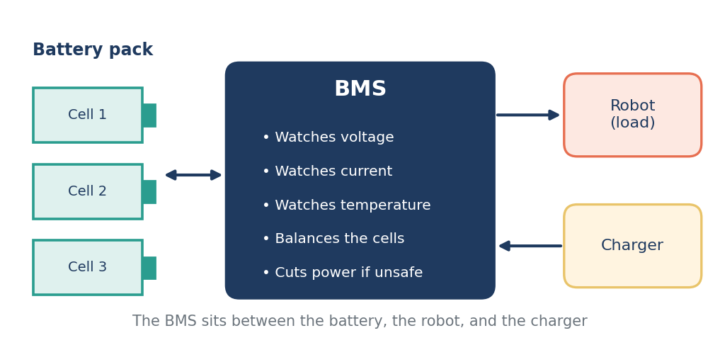
Figure: The BMS protects the battery and manages power flow between the pack, the robot, and the charger.

Computer Vision
Definition: Teaching computers to understand pictures and video from a camera. The computer sees an image as a grid of numbers (pixels) and looks for patterns in them, like edges, corners, colors, faces, or objects.
Example: In Lab 2 we draw shapes and use OpenCV to find their edges (Canny) and corners (Harris). PiDog’s camera can use the same kind of processing to spot a face or a colored ball and follow it.
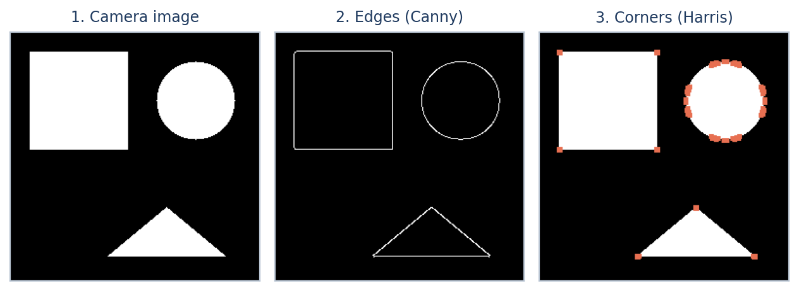
Figure: A test image made in Python, then run through an edge detector and a corner detector (like Lab 2).

Control System
Definition: The parts and rules that keep a robot doing what you want. It compares the target (what the robot should be doing) with what it is actually doing (measured by sensors), then adjusts the motors to shrink the difference. This loop is called feedback. A common type is the PID controller.
Example: A leg servo is told to go to 90° but the sensor says it is at 80°. The controller pushes the motor harder until the error is close to zero. A home thermostat works the same way.
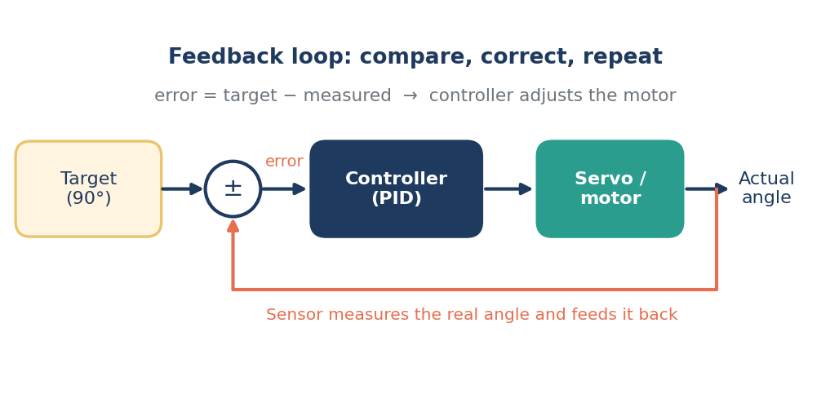
Figure: A feedback loop compares the target to the measured result and corrects the difference.

Deep Learning in Robotics
Definition: A type of machine learning that uses neural networks with many layers stacked on top of each other. Early layers pick up simple things (like edges), and later layers combine them into complex things (like a person or a wall). It works well for hard problems that are tough to write rules for, but it needs lots of data and computing power.
Example: A warehouse robot uses a deep neural network, such as a YOLO object detector, to recognize boxes and people in its camera images.
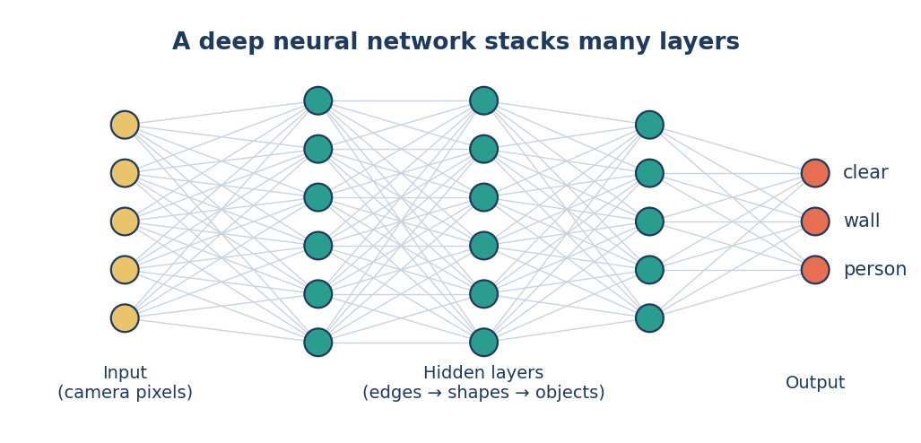
Figure: Each layer finds more complex patterns, from raw pixels up to whole objects.

End Effector
Definition: The tool at the end of a robot arm that actually touches or works on things in the world. It is like the robot’s hand. It might be a gripper, a suction cup, a welding torch, or a paint sprayer, depending on the job.
Example: A pick-and-place arm in a warehouse uses a suction-cup end effector to lift boxes. A surgical robot uses tiny grippers to hold instruments.
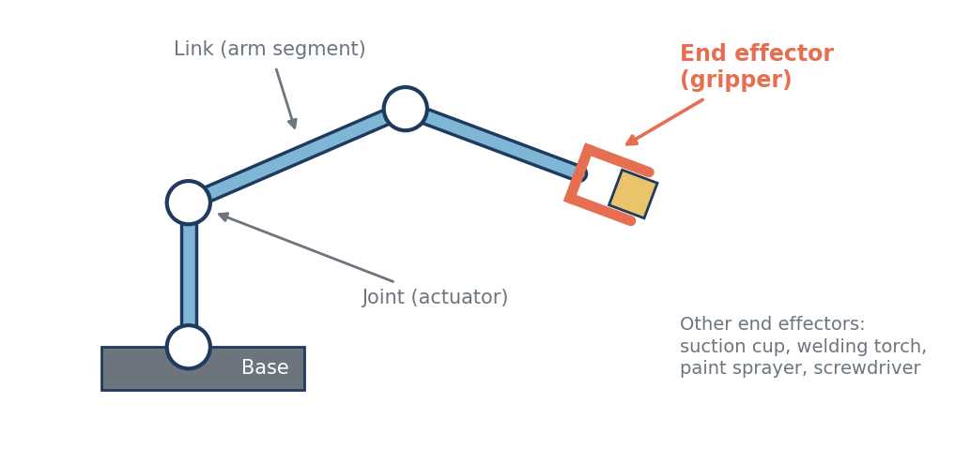
Figure: The end effector is the “hand” at the end of a robot arm.

Function Calling / Tool Use
Definition: A way for an AI model, like an LLM, to do real actions instead of only writing text. The AI is given a list of tools (functions) it is allowed to use. When a request needs one, the AI sends back a structured request (usually JSON) with the tool name and inputs. The program runs the tool and gives the result back, and the AI uses it in its answer. The AI does not run the code itself.
Example: You tell a robot assistant, “Make PiDog sit.” The LLM picks a tool called set_pose with the input “sit.” The robot code runs it, reports “ok,” and the LLM replies, “Done – PiDog is sitting.”
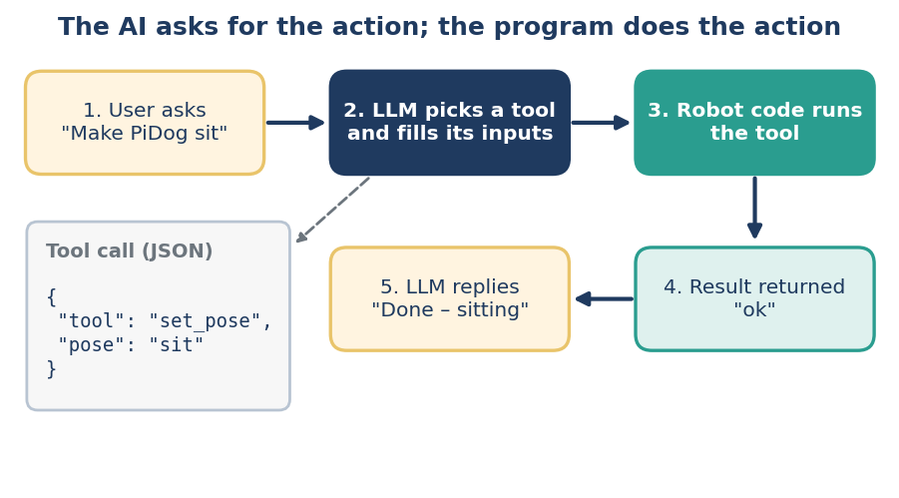
Figure: The AI asks for a tool by name; the program runs it and returns the result.

Gait
Definition: The pattern a legged robot (or animal) uses to move its legs when it walks or runs: which legs move, in what order, and with what timing. Common gaits include walk, trot, and gallop. In a trot, diagonal legs move together.
Example: PiDog’s leg servos follow a gait to walk forward or turn. The order and timing of the hip and knee movements is what keeps the robot balanced while it moves.
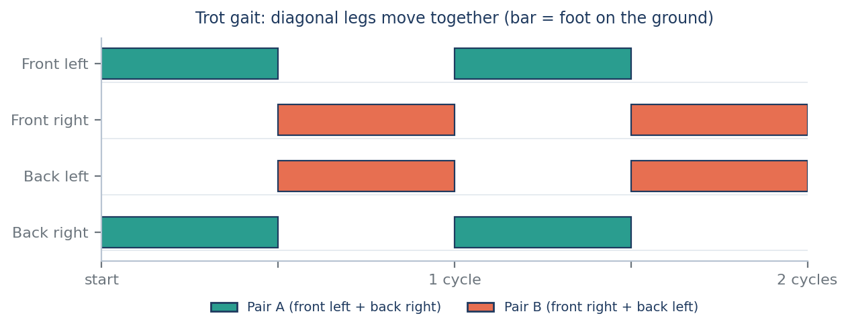
Figure: In a trot, the front-left and back-right feet step together, then the other diagonal pair.

Human-Robot Interaction (HRI)
Definition: The study and design of how people and robots communicate and work together. It covers how a robot understands people (voice, gestures, touch) and how it responds (sounds, movements, lights), plus making the experience safe, comfortable, and easy to use.
Example: PiDog has touch sensors for petting and a sound-direction sensor. When you pet it, it can wag its tail, and when you call it, it can turn its head toward your voice.
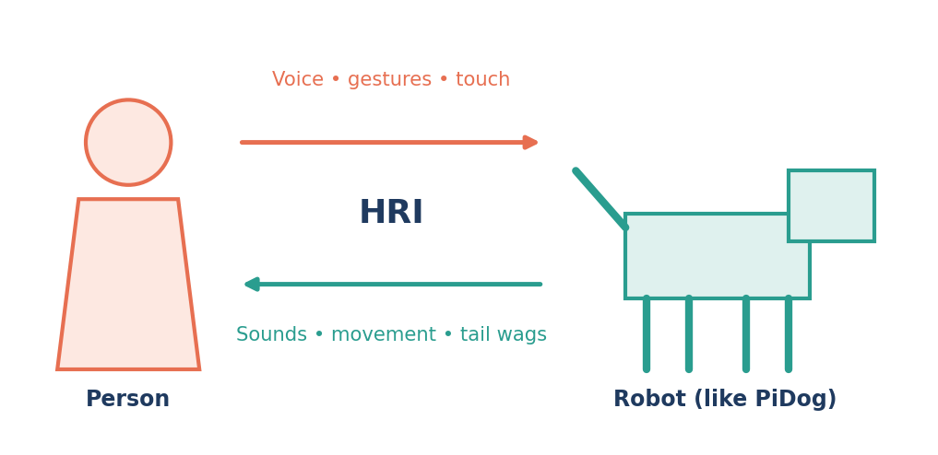
Figure: HRI covers how people and robots communicate in both directions.

Inertial Measurement Unit (IMU)
Definition: A small sensor package that measures how a robot is moving and tilting. It usually holds an accelerometer (changes in speed and the direction of gravity) and a gyroscope (how fast it is turning), and sometimes a magnetometer (like a compass). It is fast and works anywhere, but its errors slowly add up (drift), so it is often combined with other sensors.
Example: PiDog’s IMU tells it how its body is tilted, so it can stay balanced while walking and notice if it has been picked up or tipped over.
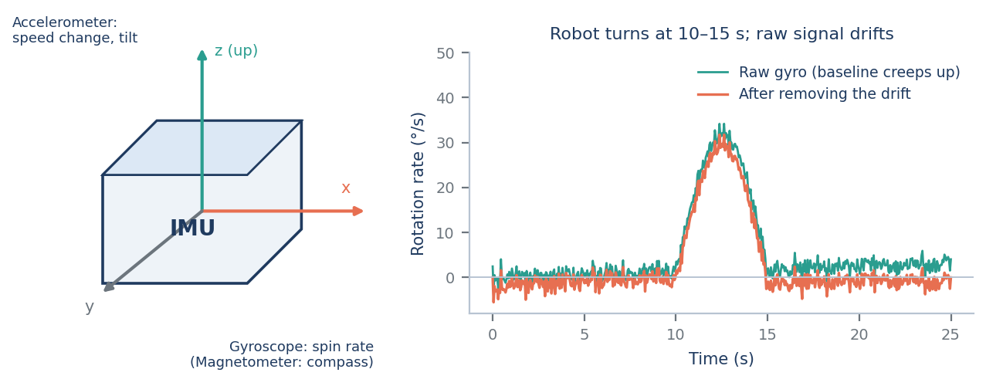
Figure: An IMU measures motion and tilt. Its raw gyro signal slowly drifts, so it needs filtering.

Kinematics
Definition: The math of motion, without worrying about forces. In robotics it links the joint angles of a robot to the position of its hand or foot. Forward kinematics: given the joint angles, where does the end land? Inverse kinematics: given where I want the end to go, what joint angles do I need?
Example: PiDog wants to place a paw at a certain spot on the ground. Inverse kinematics works out the hip and knee angles, and those angles are sent to the servos.
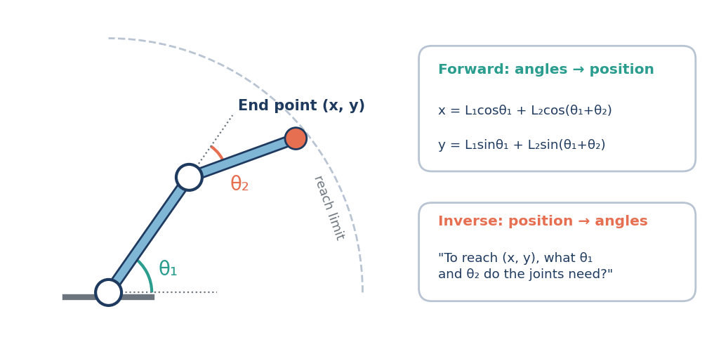
Figure: Forward kinematics turns joint angles into a position. Inverse kinematics does the reverse.

Large Language Model (LLM)
Definition: An AI model trained on huge amounts of text that can read and write language. It works by predicting the next word (or piece of a word, called a token) again and again, which lets it answer questions, summarize, write code, and follow instructions. ChatGPT, Claude, and Gemini are examples.
Example: A person says, “Go check if the door is closed.” An LLM can turn that sentence into steps the robot can follow. Because an LLM can be wrong, robots still need safety checks.
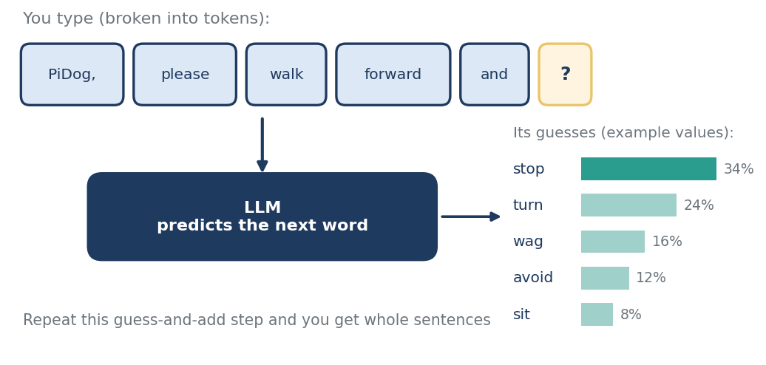
Figure: An LLM predicts the next word, over and over. (Percentages are example values.)

LiDAR
Definition: Short for Light Detection and Ranging. It sends out laser pulses and times how long the light takes to bounce back, which gives the distance. Spinning or scanning gives many distance points (a point cloud) that show walls and obstacles. It is very accurate and works in the dark, but it costs more than a camera and can struggle in heavy rain or with glass.
Example: A robot vacuum spins a LiDAR to map the walls and furniture in a room. Self-driving cars use it too. PiDog uses a cheaper ultrasonic sensor (sound instead of light) to measure distance.
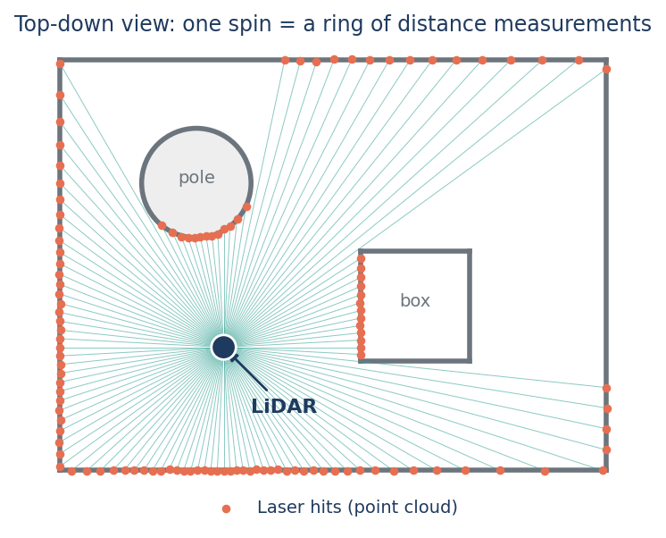
Figure: A spinning LiDAR measures distance at many angles to build a ring of points.

Localization
Definition: Figuring out where the robot is (its position and the direction it is facing) on a map. The robot combines sensor readings, such as wheel counts, IMU, LiDAR, or GPS, with what it knows about the map. GPS works outdoors, but indoors a robot needs other methods.
Example: A warehouse robot compares what its LiDAR sees to its stored map and works out, “I am at the end of aisle 4, facing north.”
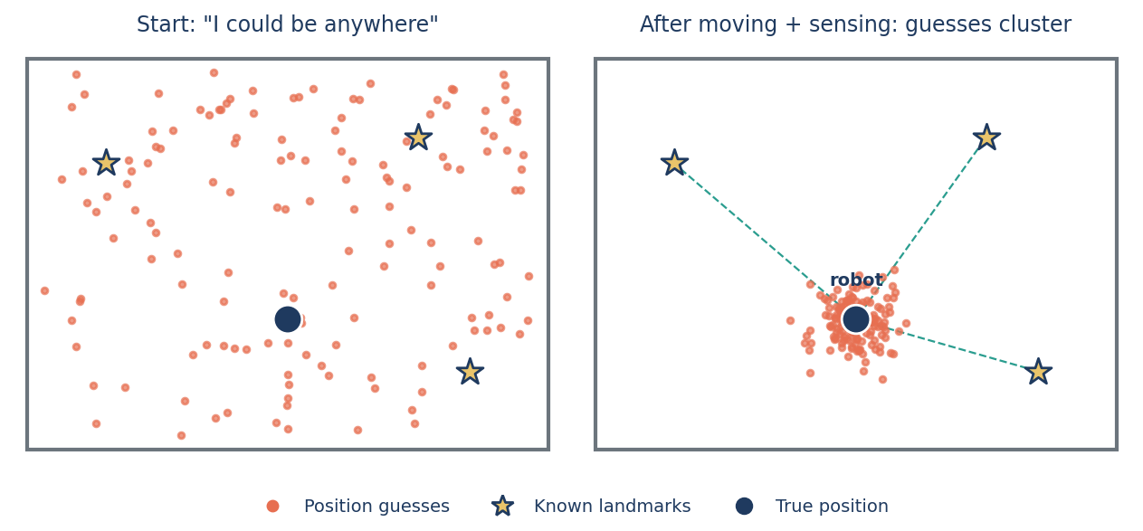
Figure: With each move and sensor reading, the robot’s position guesses cluster around the true spot.

Machine Learning in Robotics
Definition: A way for robots to learn patterns from example data instead of being programmed with every rule. You give the computer data, it trains a model, and the model then makes predictions on new situations it has not seen before.
Example: Train a simple classifier on labeled sensor readings marked “blocked” or “clear.” Later, the robot uses it to decide if the path ahead is safe. Lab 2 does something similar with scikit-learn.
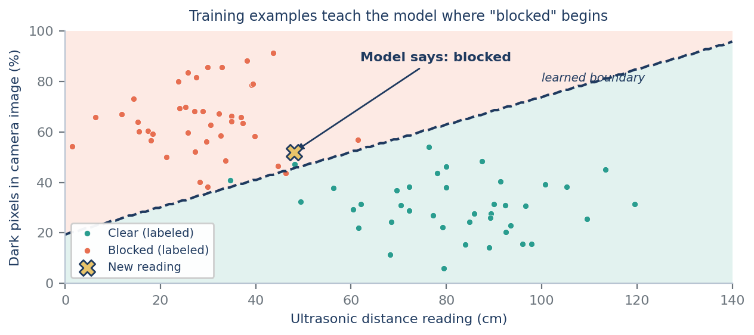
Figure: A model learns a boundary from labeled examples, then classifies a new reading.

Motion Planning
Definition: Working out a safe way for a robot to get from a start to a goal without hitting anything, while respecting its own limits (like turning radius or joint limits). Methods include graph-based planners (A*, D*) and sampling-based planners (RRT, PRM).
Example: A robot arm needs to reach a cup behind a box. An RRT planner tries many random moves, builds a tree of safe ones, and picks a path that gets around the box.
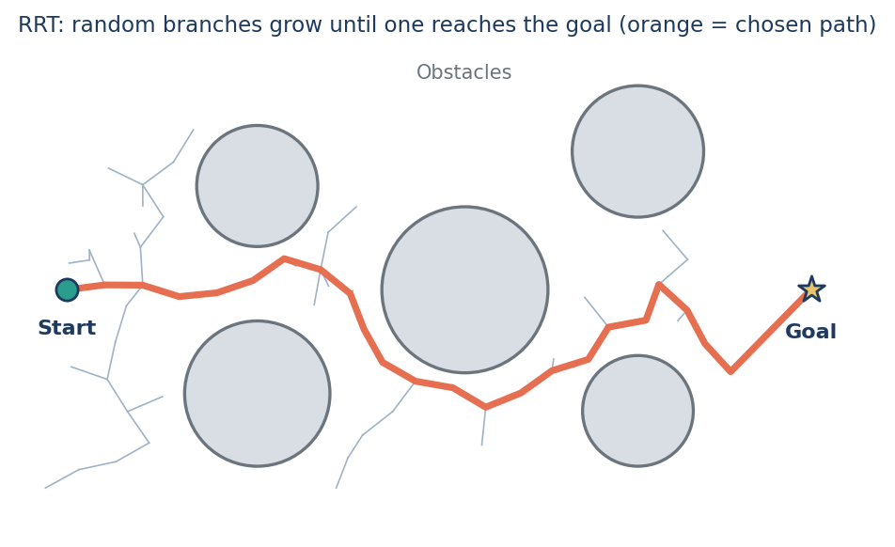
Figure: An RRT grows random branches around obstacles until one reaches the goal.

Multimodal AI
Definition: AI that can handle more than one kind of input, like text, images, audio, or video, at the same time and combine them. This is closer to how people use several senses together.
Example: Imagine telling a robot, “Bring me the red cup,” while its camera looks at a table. A multimodal model links the words to the picture and figures out which object you mean.
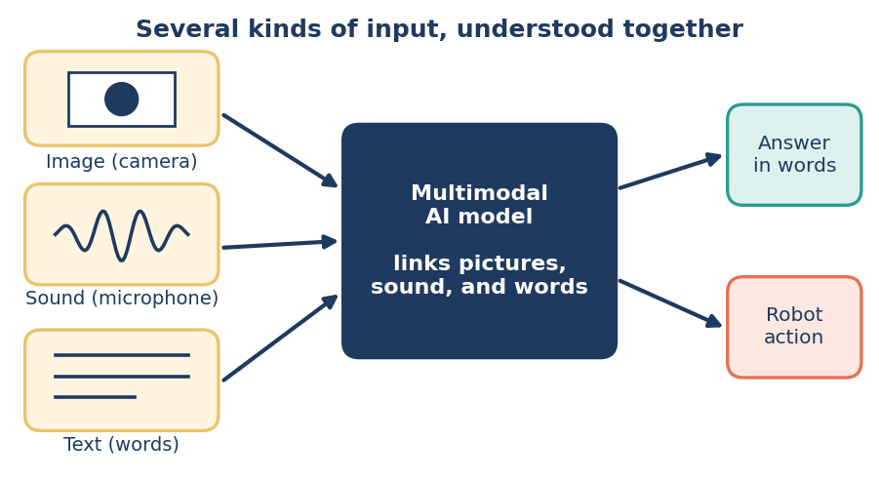
Figure: A multimodal model takes in several kinds of data and understands them together.

Pathfinding
Definition: Finding the best route between two places on a map, usually the shortest or cheapest. The map is turned into a graph or grid, and algorithms such as Dijkstra or A* search it. Pathfinding picks the route. Motion planning then works out how the robot’s body can actually move along it.
Example: A delivery robot uses A* on a grid map to find the shortest way to the charging station without going through walls. A phone’s navigation app does the same thing on roads.
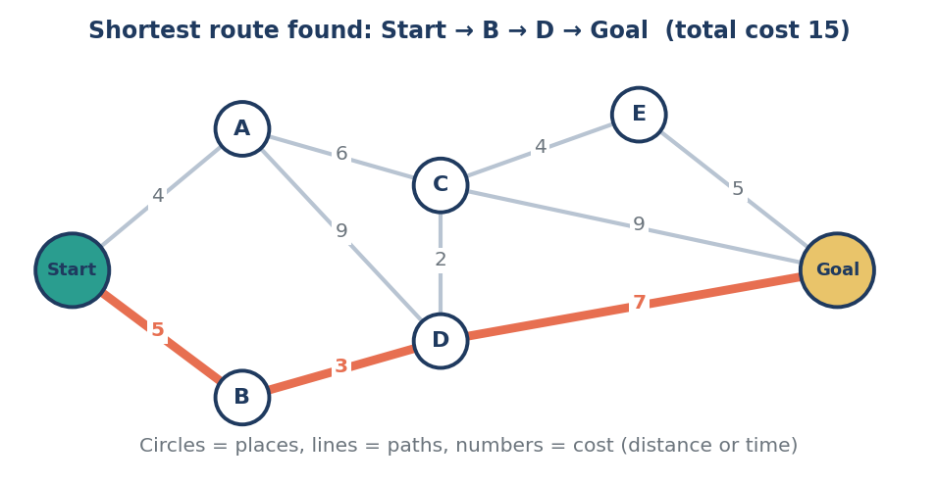
Figure: The shortest route from Start to Goal (orange) is the one with the lowest total cost.

Perception
Definition: How a robot turns raw sensor data into an understanding of the world around it. Raw readings are messy, so the robot first cleans them (preprocessing), then pulls out useful features like edges or distances, and finally decides what they mean.
Example: PiDog walks down a hallway toward a person. It smooths the camera image, filters out bad ultrasonic readings, then detects a face and decides, “Someone is about a meter ahead.”
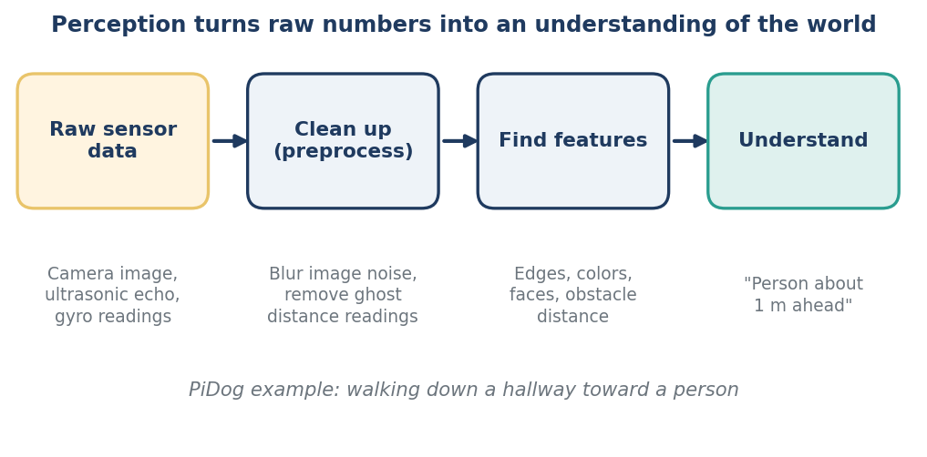
Figure: Perception steps: clean the data, find features, then understand the scene.

Reinforcement Learning
Definition: A way for a robot to learn by trial and error. It tries actions, gets a reward when things go well or a penalty when they do not, and slowly learns to pick the actions that earn the most reward. It is a bit like training a dog with treats.
Example: A four-legged robot learns to walk by earning points for moving forward and staying upright. It falls a lot at first, then gets better. This is usually done in a simulator first so no real robot gets damaged.
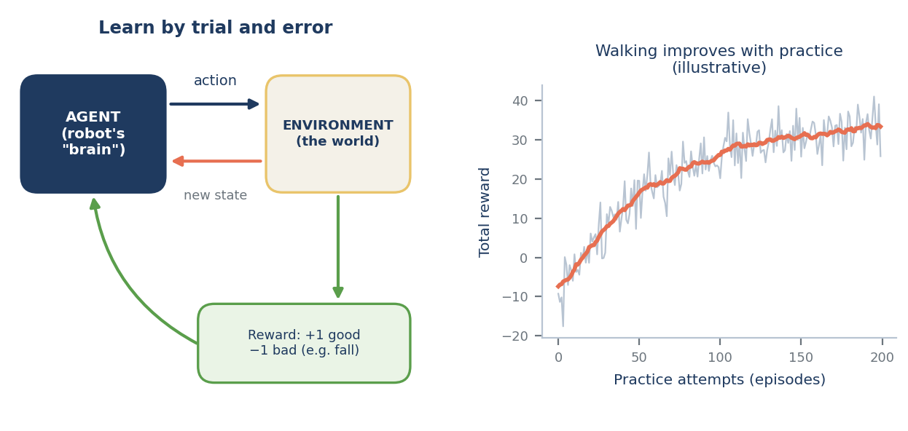
Figure: The agent acts, gets a reward, and improves over many tries.

Robotic Operating System (ROS)
Definition: Officially named Robot Operating System. Despite the name, it is not a full operating system. It is a free, open-source software toolkit that runs on top of Linux. It lets you split a robot program into small pieces called nodes, which share information through topics (publish/subscribe) and services. It also comes with tools for simulation (Gazebo), visualization (rviz), and recording data. This course uses ROS 2.
Example: A camera node publishes images on a topic. A detector node subscribes to it and publishes the obstacles it finds. A planner node listens to that and publishes speed commands. Each piece can be swapped out or tested on its own.
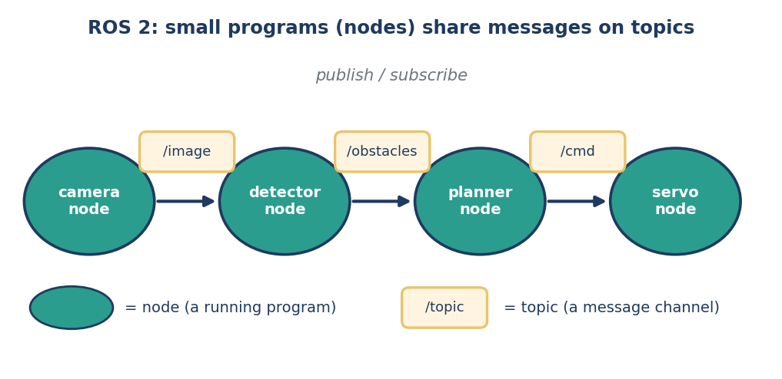
Figure: Nodes are small programs. They send messages to each other through named topics.

Sensor Fusion
Definition: Combining data from several sensors to get a more reliable picture than any single sensor could give. Each sensor has weak spots, so fusion uses the strengths of one to cover the weaknesses of another. Common methods are the Kalman filter, particle filter, and complementary filter.
Example: An IMU is smooth and fast but drifts over time. GPS is noisy and slow but never drifts. Fusing them gives a position that stays smooth and stays close to the truth (like the plot from Module 2).
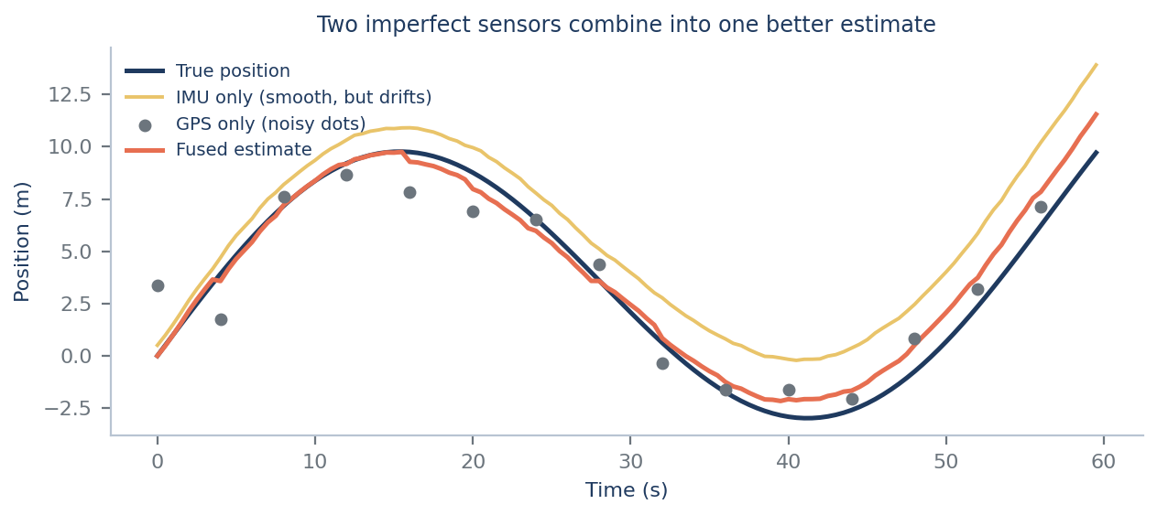
Figure: Fusing a drifting IMU with a noisy GPS gives a better estimate than either one alone.

Servo Motor
Definition: A motor with built-in position feedback that turns to an exact angle you command and holds it there. Inside is a small motor, gears, a position sensor, and control electronics. It is usually commanded with a pulse signal (PWM), and the pulse width sets the angle. The downsides are a limited range of motion (often 180°) and a torque that depends on the size.
Example: PiDog uses servos for each leg’s hip and knee, for its head (which moves the camera), and for its tail. Because servos hold exact angles, the robot can sit, stand, and walk in a repeatable way.
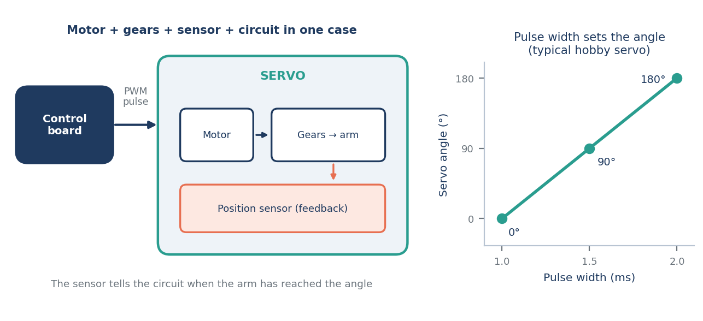
Figure: A servo has a built-in sensor. The pulse width from the controller sets its angle.

SLAM (Simultaneous Localization and Mapping)
Definition: A robot builds a map of a place it has never seen while at the same time keeping track of where it is inside that map. It is a chicken-and-egg problem: you need a map to know where you are, and you need to know where you are to build the map. SLAM solves both together, usually with LiDAR or a camera plus IMU or wheel data.
Example: A robot vacuum placed in a new house maps the rooms as it cleans and always knows which areas it has already covered.
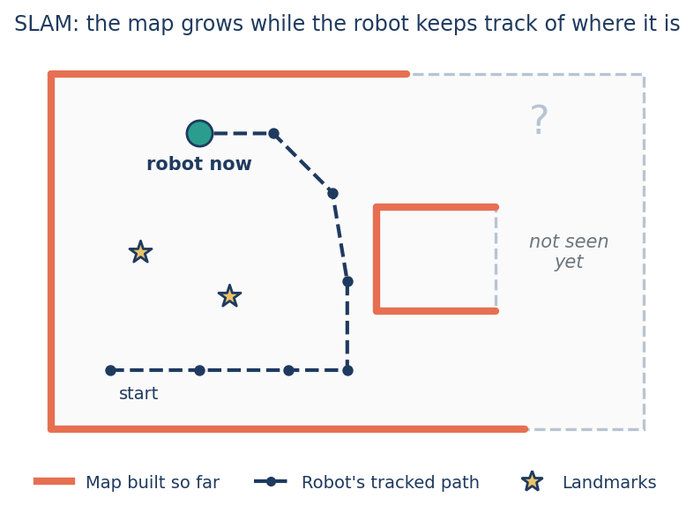
Figure: SLAM builds the map and tracks the robot’s position in it at the same time.

